1. **PRELAB**
   1. *Directions*:
      1. Answer the following questions BEFORE the corresponding lab. These are due by the time lab starts. *You may use any resource you find online or in text, but you may not work with your fellow students.*
   2. *Resources:*
      1. [Haar Cascade](https://docs.opencv.org/3.4/d7/d8b/tutorial_py_face_detection.html)

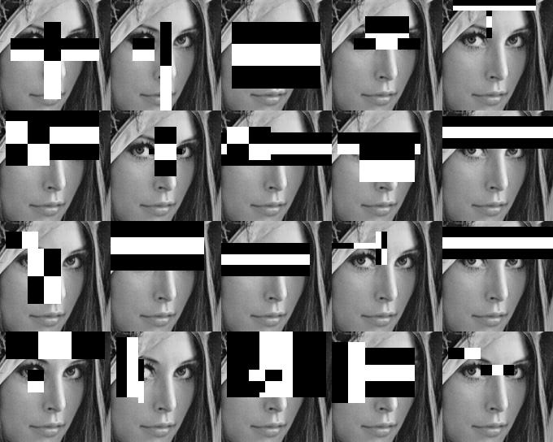

* 1. *Questions:*
     1. Haar Cascades are used by OpenCV to detect facial features. What is a Haar Cascade?
     2. How are Haar Cascades used to detect facial features?
     3. Find examples of Haar Cascades and attach them below. Explain what type of feature each cascade is used to detect.
     4. Draw a set of 4 Haar Cascades on the following picture of a dog. An example is done for you. What distinct features do dogs have that could be detected by a computer algorithm?

